**Rapid Prototyping Workshop AEM**

Prerequisites Day 5 - ASAPIO

**Checklist**

These are the steps you need to do to get the SAP system set up for the workshop.

1. Installation of ASAPIO AddOn & Solace Connector
2. Roles and Authorizations
3. RFC-Destination
4. STRUST Configuration

Follow the steps below to complete the checklist.

1. **Installation of ASAPIO AddOn, Solace Connector and Content Package**

Download and import into your SAP system from here:

https://asapio.freshdesk.com/discussions/topics/14000020247

* Framework (Only if this is your first connector)
* Connector to Solace

Or in the Workshop Content. There you will also find the Preconfigured Content as Transports.



Please import 1) and 2)

Then Activate BC-Set:

* Transaction: SCPR20
* BC-Set: /ASADEV/ACI_BCSET_FRAMEWORK_AEM.
* Activate with default settings

Then please import the Content Package Transports.

1. **Roles and Authorizations**

Add Roles and Authorizations to your SAP User and SAP Workflow User.

* At least one SAP-User will need the administrator role touse the ASAPIO Monitor

etc.: /ASADEV/ACI_ADMIN_ROLE

* Technical / system user like“WF-BATCH”or“SAP_WFRT”will need role:

/ASADEV/ACI_JOB_ROLE

https://asapio.com/docs/installation/#roles_and_authorizations

Note: If you don’t know your technical system user then go to transaction SWU3 --> Maintain Runtime Environment --> Configure RFC Destination. This needs to be generated and on the right side it will show you the technical system user.

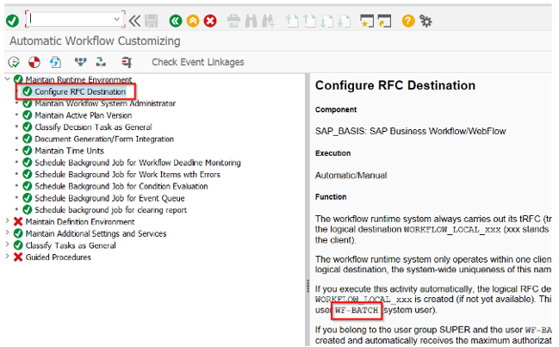

1. **RFC-Destination**

Create a new RFC destination of type “G” (HTTP Connection to External Server) i Transaction: SM59

Specify Target Host and Service No. (Port): endpoint for the SAP Advanced Event

mesh

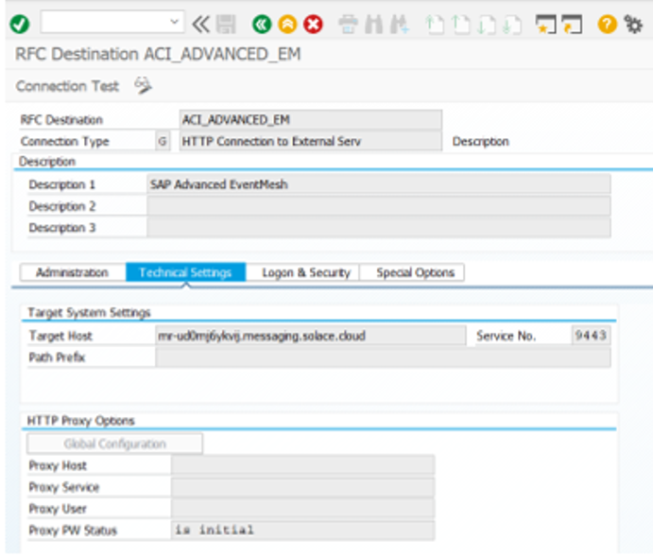

- Credentials or certificates for authentication can be specified on tab Logon & Security:

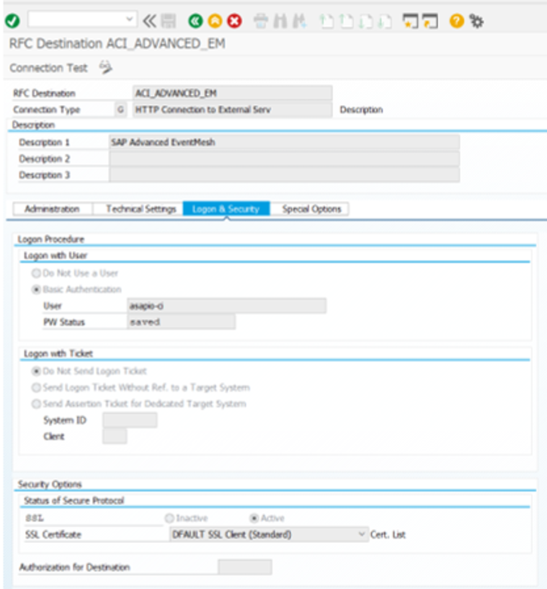

When activating SSL please ensure that the necessary certificates are in the selected Certificate List (keystore) in your SAP system. To get the necessary certificates for the https/SSL connection you can follow the next section to download them via your browser. Browser specific way toget a certificate.

1. **STRUST Configuration**

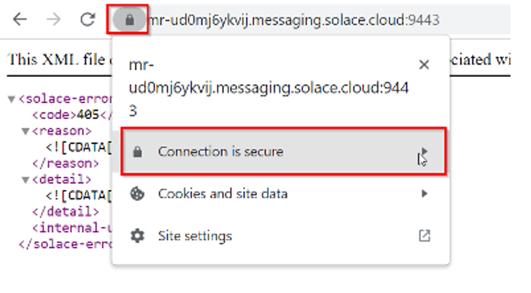

Click on Certificate is valid.

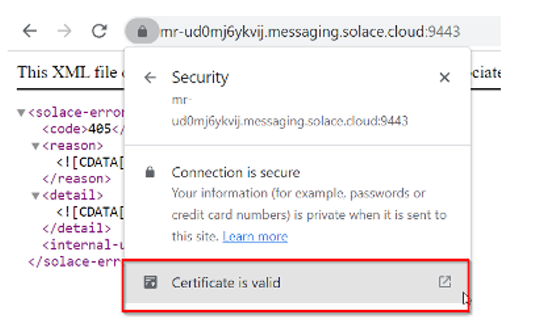

Go tothe Details tab and export the file to save it.

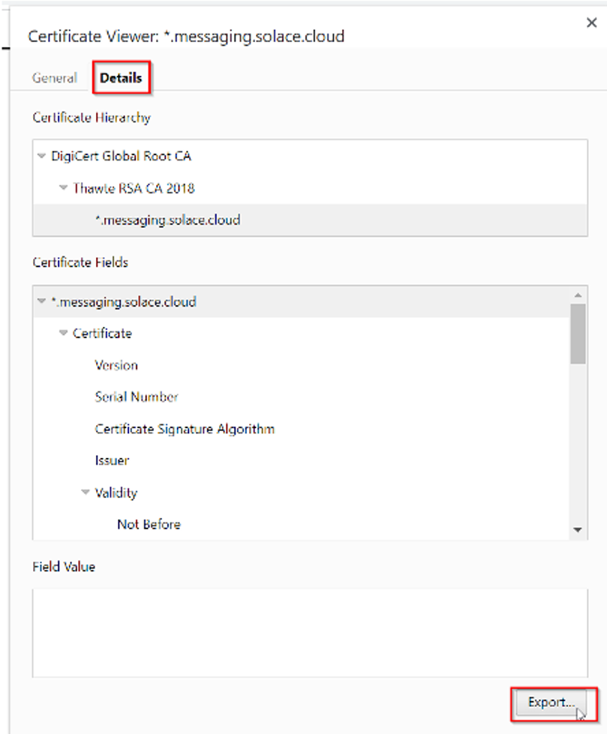

In the next step this certificate can be added to the Trust Store in SAP.

Add Certificates toTrust Store

* + Transaction: STRUST
  + Select Certificate List as used in RFC destination created above
  + Click button Import certificate (1)
  + Click button Add to Certificate List (2)

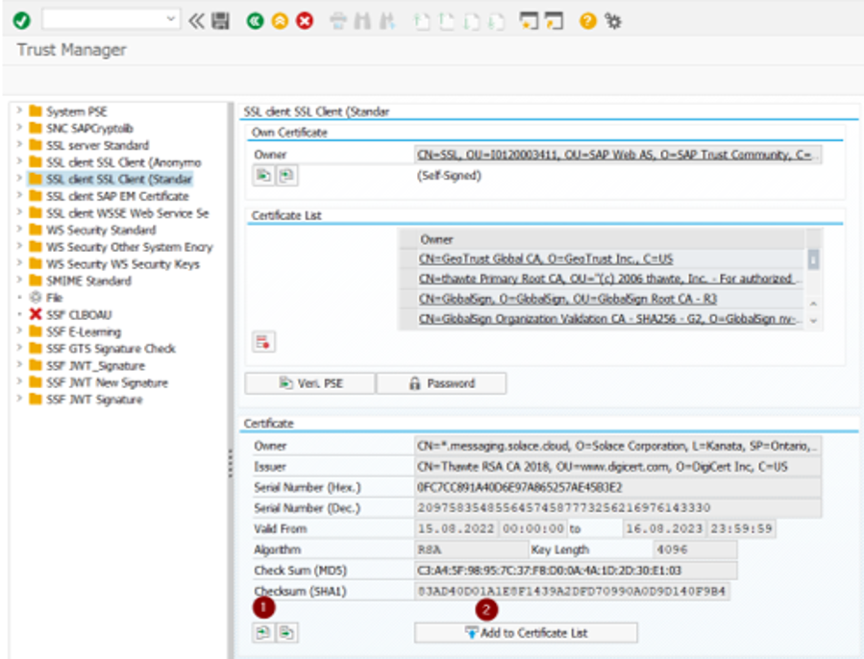

After adding the certificates, you will receive a 405 “Method not allowed” in the connection test of transaction SM59, which is correct as this means it’s reaching the ‘Advanced Event Mesh, The Asapio Integration Add-On will later build the complete URL together leading to a successful response with a 200.

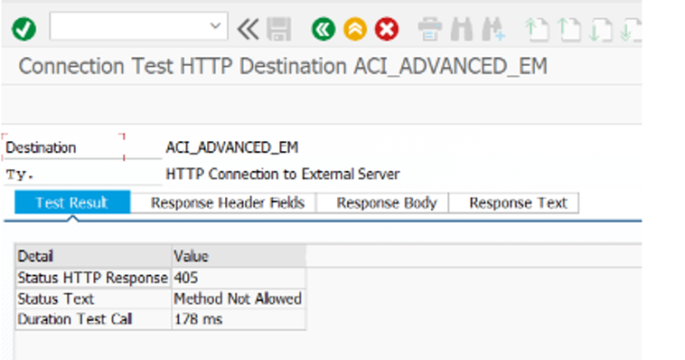

Here we can see it in transaction /n/asadev/aci_monitor which is explained later in this document.

